Name: Milan Gocic
E-mail: milan.gocic@gaf.ni.ac.rs
Institution: University of Nis, Faculty of Civil Engineering and Architecture
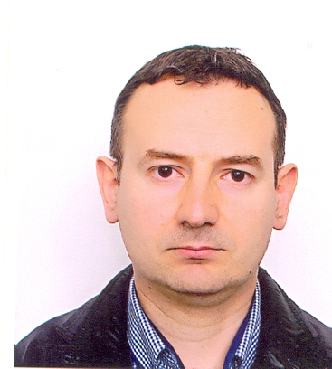 | Milan Gocic, PhD, assistant professor at the University of Nis (Faculty of Civil Engineering and Architecture), has research experience in hydroinformatics, data mining and analysis of hydrological hazards. He is the author of more than 100 papers in the field of hydroinformatics, of each 21 were published in international journals with impact factor. He worked as a Guest Editor for the Special Issue in Advances in Meteorology (“Hydrological Hazards in a Changing Environment: Early Warning, Forecasting, and Impact Assessment”) and as a reviewer for twenty international scientific journals. He took part in three international projects: COST, TEMPUS SCM, CEI Cooperation Activities and six scientific projects financed by the national Ministries. He was a coordinator of one international and three national projects oriented to cluster development in Serbia. He was a member of organization and scientific committees of four international conferences. Currently, he is a member of the national project supported by the Serbian Ministry of Education, Science and Technological Development entitled “Development of hydro-information system for monitoring and early drought warning” and member of the Management Committee of the ICT COST Action IC1408 supported by the EU Framework Programme Horizon 2020 entitled “Computationally-intensive methods for the robust analysis of non-standard data (CRoNoS)”. He is one of the inventors of new drought index titled “Water Surplus Variability Index”.
References (max. 5 relevant references)
1. Gocic, M., Trajkovic, S., 2015. Water Surplus Variability Index as an indicator of drought. Journal of Hydrologic Engineering 20(2), 04014038.
2. Gocic, M., Motamedi, S., Shamshirband, S., Petkovic, D., Ch, S., Hashim, R., Arif, M., 2015. Potential of adaptive neuro-fuzzy inference system for evaluation of drought indices. Stochastic Environmental Research and Risk Assessment 29(8), 1993-2002.
3. Gocic, M., Trajkovic, S., 2014. Spatiotemporal characteristics of drought in Serbia.Journal of Hydrology 510, 110-123.
4. Gocic, M., Trajkovic, S., 2014. Drought characterisation based on Water Surplus Variability Index.Water Resources Management 28(10), 3179-3191.
5. Gocic, M., Trajkovic, S., 2013. Analysis of precipitation and drought data in Serbia over the period 1980–2010.Journal of Hydrology 494, 32-42.
This project has been funded with support from the European Commission. This publication reflects the views only of the author, and the Commission cannot be held responsible for any use which may be made of the information contained therein.

